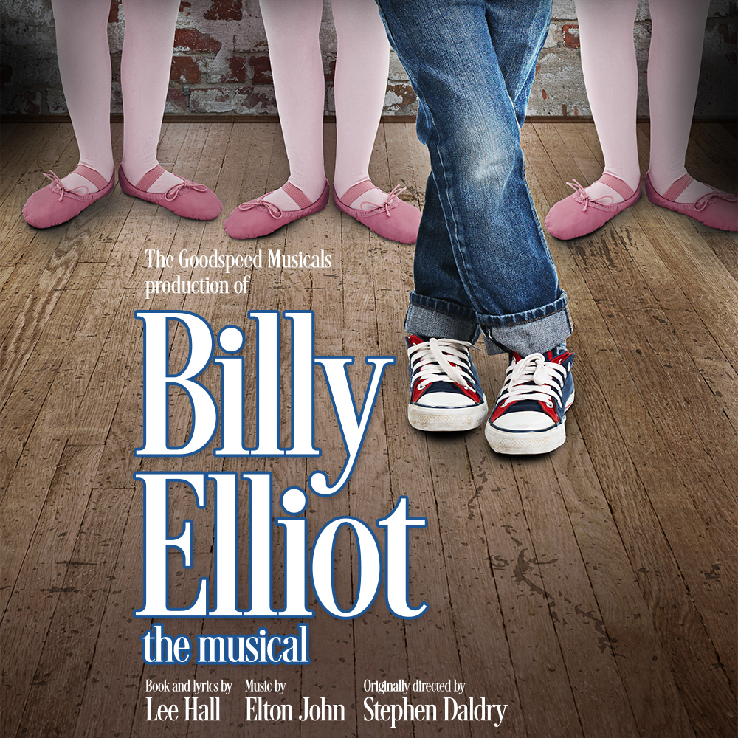­­­

**GOODSPEED MUSICALS PRESENTS**

***Fill in your group’s information below and print on legal size paper.***

**Your Organization Name**

**Performance Date, 00:00 PM**

$00.00

***Event Details:***

Young Billy Elliot is pulled between his family’s coal-mining roots and his newly discovered passion to dance. Is his future boxing gloves or ballet shoes? In the hardscrabble world of a changing England, reaching high becomes a leap of faith. Following your dream—and overcoming obstacles—has never been more electric than in the 10-time Tony winning Broadway phenomenon with songs by the legendary Elton John. Celebrate the idea of being yourself in the Goodspeed premiere of this powerful dance-filled story!

*Your Contact Info*